Mexico City, June 17, 2015

Tickets sale for the FORMULA 1 GRAN PREMIO DE MEXICO 2015 ® begins tomorrow, on June 18th, through Banamex Pre-sale and Superventa Santander, the general sale begins on Saturday, June 20th.

- The Superventa Santander and Pre-sale Banamex will grant both banks cardholders the opportunity to purchase them in 6 months without interests as much for pre-sales as for general sale.
- General sale begins on June 20, with all payment methods either through the Ticketmaster webpage or at the box-office number 7 in Palacio de los Deportes.

We are a few hours away from the beginning of the new tickets sale for the FORMULA 1 GRAN PREMIO DE MEXICO 2015®. This new offer will sell tickets for all localities ensuring enough entries for both phses pre-sale and general sale.

During the Superventa Santander and Pre-sale Banamex cardholders for both banks will have the chance to purchase their tickets in 6 months without interests on the web page Ticketmaster, as much for the pre-sale phase as for the general sale phae on June 18th and 19th.

Ticketmaster is able to assist up to 4,500 people simoultaneously in their pone platform, internet, points of sale and box office. So we recommend the pre-sale.

Please remember tickets can be purchased on the Ticketmaster center only, from 11:00 o’clock for both phases pre-sale (June 18 and 19) and general sale (from June 20).

General sale will be available from June 20 with any payment method.

Tickets will be available for sale in:
- www.ticketmaster.com.mx
- Ticketmaster Centers
- Ticketmaster Call centers: 55 53259000
- Box-office number 7 located in Palacio de los Deportes

For further information about new localities, pleas enter www.ahr.mx

Ticket | Price MXN (3-day entry)
General Entry Stand | $1,500.00
Foro Sol South Stand | $4,500.00
Foro Sol North Stand | $6,500.00
Gold Stands | $9,000.00
Platinum Stand  Main Grandstands | $12,000.00  $18,750.00 plus right to reserve.
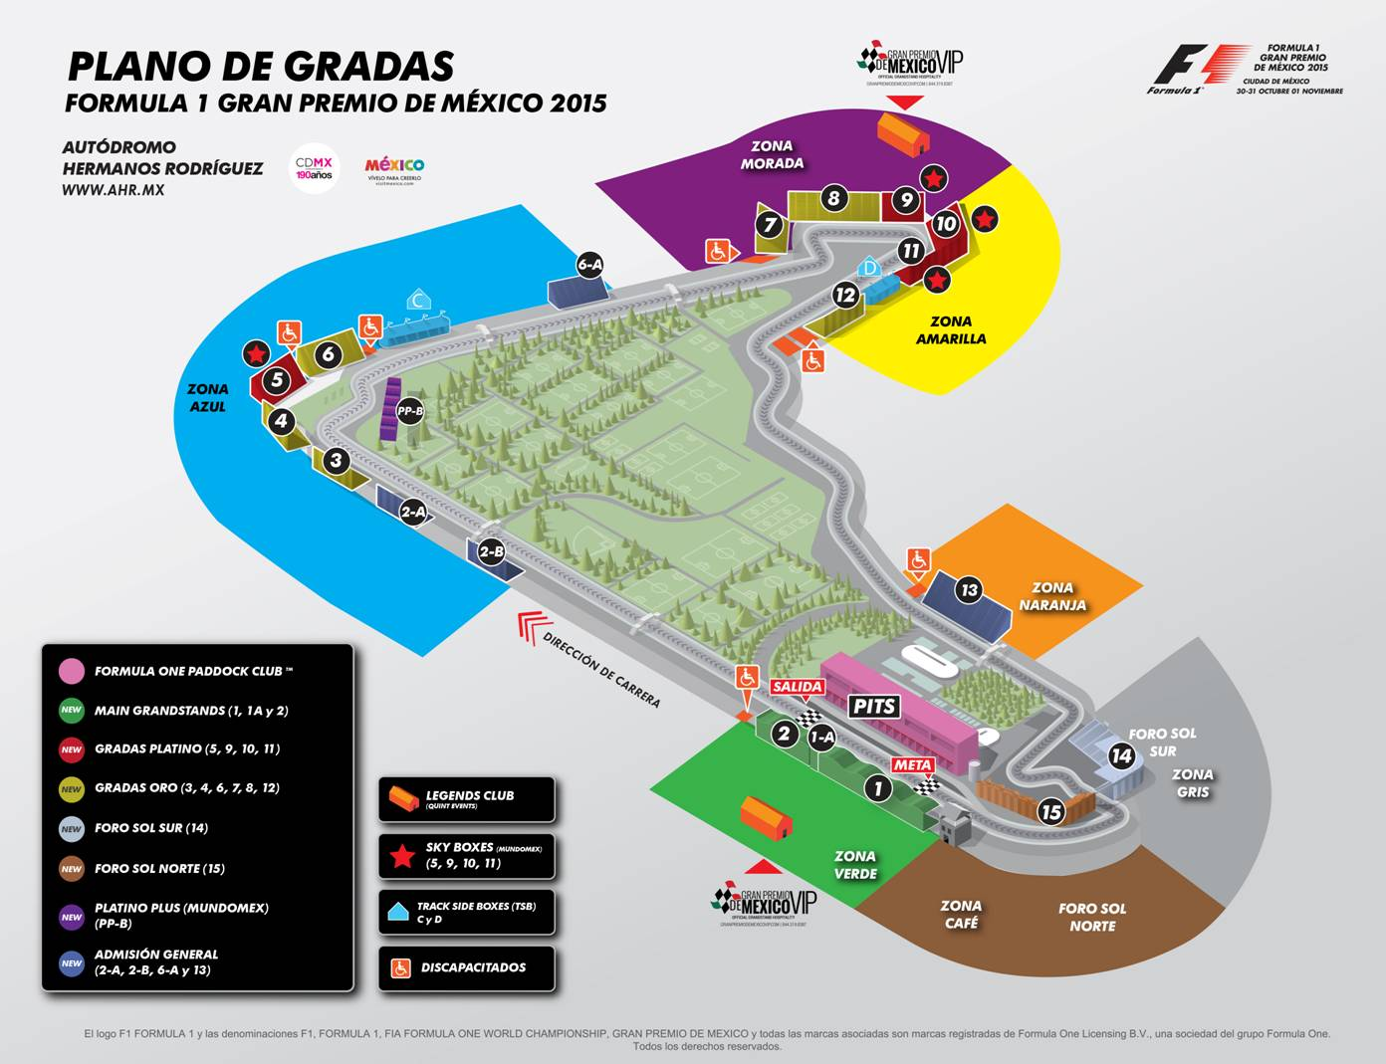

In addition to this, we have different corporate packages, which include hospitality options around the track. For further information please call 21221505 or visit sales@ahr.mx.

CIE has also established a partnership with QuintEvents to offer hospitality packs under a new VIP GRAN PREMIO DE MEXICO program. This program offers an additional batch of tickets with exclusive access to the race and special events. Which include lodging in Mexico City among others and exclusive access to the Legends Club to enjoy unique experiences such as a lunch with a question and answer session with the FORMULA 1® legend, Emerson Fittipaldi.

There is also a partnership with Mundomex that will offer exclusive Boxes in the “Platinum Plus Oasis” section placed in the inner section of the complex Moisés Solana, and panoramic Sky Boxes in stands 5, 9, 10 and 11.

Thanks to the collaboration of Corporación Interamericana de Entretenimiento (CIE) with NUSSLI, one of the most prestigious stand builders in the world, seating capacity will be maximized at the Autodromo Hermanos Rodriguez in a 10%.

With NUSLI assessment and technology, there will be different improvements to make the place more efficient and increase the seating capacity in different areas without affecting previously purchased tickets.

Changes to be made:

- Connection of stands 1 and 2 to increase Main Grandstand number of tickets.
- The integration of a new stand to the General Entry 2B, place at the main straight.
- The General Entry 6A stand at the infield of the complex Moisés Solana was moved to the short straight in order to streamline its capacity.
- Expansion of the spaces with new seats in the Forum, North and South Zone.
- Renewal of stand 9 including a continuous stand in the stadium section corresponding to stands 10 and 11.
- The improvement of the space and isoptic of the stands, increasing the seating capacity in different zones of the racetrack without affecting previously purchased tickets.
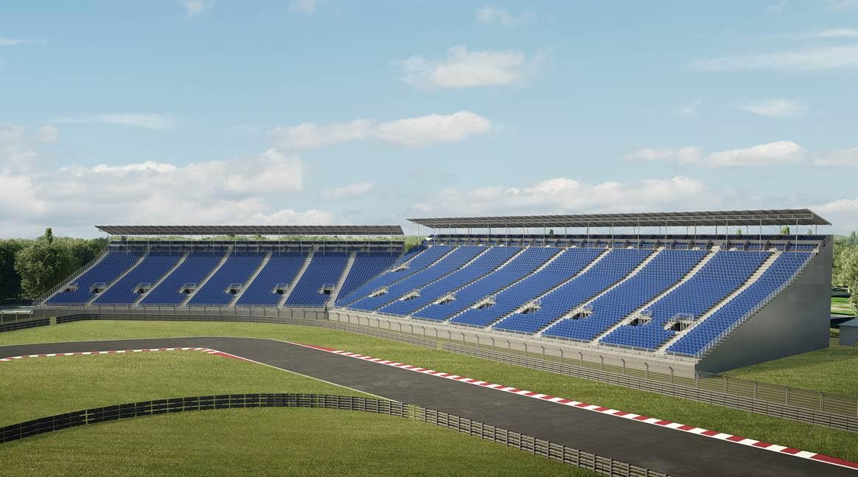
Unión grada 10 y 11 con Sky Boxes

Visit and enjoy Mexico with the FORMULA 1 GRAN PREMIO DE MEXICO 2015.
www.ahr.mx
Facebook: Autodromo Hermanos Rodriguez
Instagram/Twitter: @autodromohr
#MexicoGP

Download render and stand maps in the following link:http://we.tl/4jHR8Sqf8O

Contacts
Francisco Velazquez  fvelazquezc@cie.com.mx  (52 55) 52019089  CIE | Manuel Orvañanos  manuel@bandofinsiders.com  (52 55) 63866686  Band of Insiders

About CIE
Corporación Interamericana de Entretenimiento, S.A.B de C. V.
www.cie.com.mx
We are the market leader in outdoors entertainment in Mexico, Colombia and Central America and one of the most outstanding participants in Latin America and worldwide entertainment industry.
Through a unique vertical integration model, and the only Access to an important network of entertainment centers, a base of advertisers formed by the main advertising investors in our market, as well as the alliances and strategic partnerships that we have established with experienced participants in global industry; we offer different world-class entertainment options, which include concerts, theater productions, sports, family and cultural events, among others to satisfy leisure and recreation needs for our audiences.
We operate an amusement and an aquatic park in Bogota, Colombia. Also, we commercialize the Banamex Center in Mexico City, one of the biggest and most important exhibition and convention venues internationally. In addition we are recognized as the foremost producer and organizer of special and corporate events in Mexico, and for operating one of the most professional contact centers recognized in the Mexican Market.
CIE is a public Company whose shares and debit securities are listed in the Mexican Stock Exchange.
About NUSSLI

NUSSLI is a leading global supplier of temporary structures for events, fairs and expositions. The combination of a large experience, depth knowledge and an international network ensures focused, cost-effective implementation of customer’s specifications. NUSSLI’s success is driven by reliability and unwavering commitment of resolution. The company offers individual and personalized solutions integrated from the initial concept to final execution. All these projects are characterized by short-term execution deadlines and unparalleled quality.

NUSSLI final products are based in grandstands and modular stadiums, fair stands and pavilion constructions, including the entire infrastructure for events. A wide range of services and products combined with the planning and in-house production leaving NUSSLI as unparalleled in events around the world.

NUSSLI is headquartered in Switzerland. In addition to international subsidiaries in Germany, Austria, Czech Republic, Spain, Italy and the US, the company is represented by sales, offices and projects worldwide partners.

About QuintEvents

QuintEvents have been selected by CIE, to develop and promote Travel packages/experiences for a prominent international career, the FORMULA 1 GRAN PREMIO DE MEXICO™. QuintEvents is proud to be the Official Global Hosting Provider for the inaugural FORMULA 1 GRAN PREMIO DE MEXICO™. QuintEvents develops top-class experiences packs and exclusive extras directly from the source! Using our unique collaborations with some of the biggest names in entertainment and sports, we offer travel packs and lodging giving our customers entrances, large blocks of seats, the best hotels, celebrities’ appearances, and privileged access, access to exclusive parties at the most prestigious events in the world and other access that turns an event into a whole “Experience.””

QuintEvents is proud to be the Global Hospitality Official Provider for the FORMULA 1 GRAN PREMIO DE MEXICO 2015™, being the NFL Experiences Event Official Provider On Location, for different events including Super Bowl, Pro Bowl, Draft, International Series and the Pro Football Hall of Fame Enshrinement Weekend, Churchill Downs® Experiences Packages

Official Provider for Kentucky Derby® and the Kentucky Oaks®, NBA Hospitality Official Provider for the NBA All-Star Game and Draft, the Exclusive Official Provider of Entrances, Lodging and Travels for the Circuit of the Americas™ for FORMULA 1 UNITED STATES GRAND PRIX™, United SportsCar Racing Series, and MotoGP™ races series, a Formula One Paddock Club™ Authorized Agent for the FIA FORMULA ONE WORLD CHAMPIONSHIP™, Authorized Agent for the MotoGP VIP Village™ for 18 races all around the world, the Exclusive Official Provider of Entrance packs, hospitality and travels for the Breeders’ Cup®, Exclusive Official Provider of Entrances packs, hospitality and travels for the UFC® College Football Playoff Premium Events and Experiences VIP, Official Experience Provider for the College Football National Championship Game, and Barrett-Jackson Entrances, hospitality and travels Official Provider for the Scottsdale Collector Car Auction.

Sobre Mundomex

Throughout over four decades of life, Mundomex has integrated a diversified Company in travel services such as: professional consulting for small, medium and large corporations, development of attractive vacation packages, conventions organization in Mexico or any other place in the world and touristic options for foreigners.

We currently have over 120 highly trained employees, offering an integrated service with advanced technology in different areas.

We constantly seek for innovation and success, based on our customers’ needs in order to provide them a quality service that exceeds expectations and create value. We want to be consolidated as the best travel company and production with the ability to provide services solutions with the highest levels of quality.

