Mexico City, October 31,2015

With an impressive seating capacity that exceeded expectations on the second day of the FORMULA 1 GRAN PREMIO DE MEXICO 2015®

Checo Perez from the 9th position hopes to give his best race tomorrow.

111,964 fans were gathered together today to support their favorite on the qualifying round of the FORMULA 1 GRAN PREMIO DE MEXICO 2015®, which confirms a strong fancy for the maximum motorsports category

Nico Rosberg beat his team mate Lewis Hamilton and assured the pole position for tomorrow’s Grand Prix; on the other hand Mexico beat the world, when Felipe Massa set the record with the fastest speed of the season during qualifications, reaching the 360 kilometers per hour.
Mexicans celebrated Checo Perez’s time of 1:20.716 which will place him in the ninth position. While, Daniil Kvyat assured the fourth position of the grid, third for Vettel and fifth for his teammate Daniel Ricciardo. Williams’ Valtteri Bottas is going close to his teammate, the Australian, Felipe Massa, who is starting one position right after him. Max Verstappen from Scudery Toro Rosso kept the eighth place, leaving the last two positions of the starting grid for Force India’s cars. The first driver eliminated from today’s session, was McLaren’s Jenson Button.
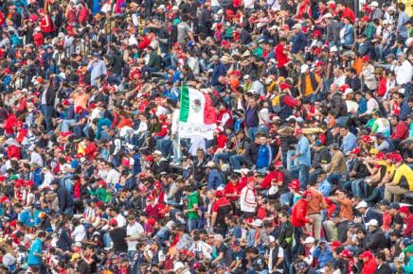
The vive came swiftly in all sections of the Autodromo Hermanos Rodriguez, where flags, blankets, supporting and encouraging shouts ignited everyone’s sparkle.

Meanwhile, at the beginning of the day on the Masters Historic Racing, Aaron Scott became the first winner of the weekend, for he took advantage of the first position driving his March 761 at the maximum speed and claiming victory from there on the 10-laps Masters Historic Racing. Luis Leeds from Australia set a time record during the session of FIA Formula 4 Championship NACAM to take place tomorrow.

Among the celebrities and personalities who attended the FORMULA 1 GRAN PREMIO DE MEXICO 2015® today, we could find former president of Mexico, Felipe Calderon and his wife Margarita Zavala, Mexico City Mayor, Miguel Angel Mancera, Jacqueline Bracamontes, Eric Rubin and Alejandro Nones.
Mexico and the world wait anxious for tomorrow’s race to celebrate the winning driver of the FORMULA 1 GRAN PREMIO DE MEXICO 2015® to support Checo Perez in every time #VamosconCheco.

¡ FORMULA 1 undoubtedly arrives to Mexico to stay!

Visit and Enjoy Mexico with the FORMULA 1 GRAN PREMIO DE MEXICO 2015®.
In case of further doubts please call the toll-free number 01 800 777 77 F1

www.ahr.mx
Facebook: Autódromo Hnos Rodríguez
Instagram/Twitter: @autodromohr
#MexicoGP

Contacts
Francisco Velázquez  fvelazquezc@cie.com.mx  (52 55) 52019089  CIE | Manuel Orvañanos  manuel@bandofinsiders.com,  (52 55) 63866686  Band of Insiders

About CIE
Corporacion Interamericana de Entretenimiento, S.A.B de C. V.

www.cie.com.mx
We are the market leader in outdoors entertainment in Mexico, Colombia and Central America and one of the most outstanding participants in Latin America and worldwide entertainment industry.
Through a unique vertical integration model, and the only Access to an important network of entertainment centers, a base of advertisers formed by the main advertising investors in our market, as well as the alliances and strategic partnerships that we have established with experienced participants in global industry; we offer different world-class entertainment options, which include concerts, theater productions, sports, family and cultural events, among others to satisfy leisure and recreation needs for our audiences.
We operate an amusement and an aquatic park in Bogota, Colombia. Also, we commercialize the Banamex Center in Mexico City, one of the biggest and most important exhibition and convention venues internationally. In addition we are recognized as the foremost producer and organizer of special and corporative events in Mexico, and for operating one of the most professional contact centers recognized in the Mexican Market.
CIE is a public Company whose shares and debit securities are listed in the Mexican Stock Exchange.

