Mexico City to 14 July 2016.

Tell me who you are going to the FORMULA 1 GRAND PRIX OF MEXICO 2016™ and I will tell you that experience choose

The date most awaited by lovers of cars and the speed in Mexico is increasingly near: THE FORMULA 1 GRAND PRIX OF MEXICO 2016™.
The F1THIS of motorsport - so called not only for those who lived through the return of the Formula 1® to our country in 2015, but also by such personalities as Lewis Hamilton, Nico Rosberg or the own Bernie Ecclestone - will return to switch on again the motors and the emotion the 28, 29 and 30 October.
This year there will be FORMULA 1 GRAND PRIX OF MEXICO 2016™ for all regardless of the level of your passion for motorsport - either that collections toy wagons, tunees your car to the style bling bling of Hamilton or you get up in the morning to see live every detail of the races.
However, it is important that depending on the type of experience you want live choose with whom attend the F1this, since it is not the same go in ball with your friends that invite your father or your nephews to be well with the bride.
Whatever the case, there is a special place for all at the Autodromo Hermanos Rodriguez. Then will advise you about what places are the most appropriate to the memories you want to create.
a) Novi@. For you to leave impresionad@ to your companion we recommend you to go to the area Speed lovers, since it was here that may get excited together with the step of the cars at full speed and see the braking first heading to the curves of the track. In addition, this area is very close to the F1 Village, where you can find a wide range of dining and dancing to the rhythm of the multiple bands that play live on stage.

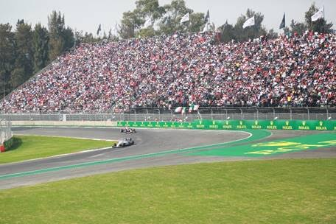

b) Friends. Definitely the best place to enjoy with Los Cuates is in Euphoric Fans. Here you will be able to sing the name of "Czech" to get out of breath, assemble the wave as in the stadium and carry accessories to support your pilot or favorite team. In addition may be taken selfies and record videos of the award for presumirlos with those who did not want to go with you.
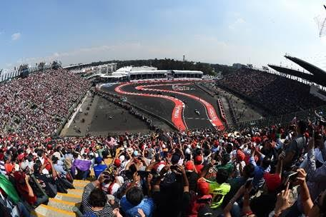
.

c) Family. If you want to go in family plan, it is best to reach the area True from where you can teach it Racers to your children, nephew or grandchild the real thrill of motorsport. To be the more technical part of the circuit, is ideal to analyze every detail of the skills that are needed by the pilots. It is also next to the F1 Game Zone, where you can lay retas on the simulators, test your ability as a technician of pits or buy official merchandise.

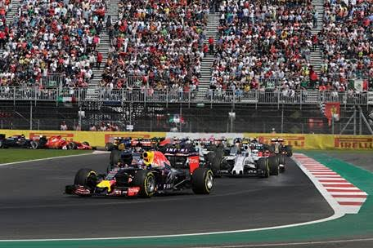

D) Boss. If what you want is to be well with your jef@, definetly go to the VIP area Party Racers, because here will enjoy a more intimate and glamourous. The best element is undoubtedly its privileged view of the pits with which you can look to explain every detail of the moment they arrive the cars to this place and all they have to make them in less than 5 seconds to continue the race.

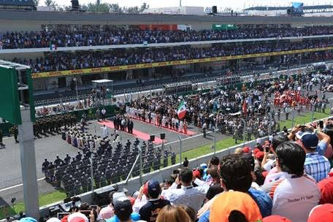

Once you have defined your profile and your passengers can enjoy to the maximum the three days of event. So no matter if you decide to go to consent to your girlfriend or make the beard to your boss, the important thing is that you enjoy and become a part of one of the most emblematic sporting events at the global level, the FORMULA 1 GRAND PRIX OF MEXICO 2016™.

Do not you stay outside the FORMULA 1 GRAND PRIX OF MEXICO 2016®!

Tickets are on sale through the Ticketmaster network in the web page www.ticketmaster.com.mx, Ticketmaster centers authorised in the phone 5325 9000 or at the box office no.7 located in the Palais des Sports.

Consultation More information of the location of your tickets at www.mexicogp.mx

Corporate Packages available with:
Diego Perez
Dperez@cie.com.mx

-or-

www.mexicogp.mx
Facebook: mexicogp
Instagram/Twitter: @mexicogp
#MexicoGP #F1this

Contact:
Francisco Velázquez
Fvelazquezc@cie.com.mx
(52 55) 52019089
CIE Manuel Orvañanos
Manuel@bandofinsiders.com
(52 55) 63866686
Band of Insiders

On CIE
Inter-American Corporation of Entertainment, S.A.B of C. V.

www.cie.com.mx
We are the leading company in the market of entertainment outside the home in Mexico, Colombia and Central America and one of the key participants in the Latin American context and global in the Indust

Sobre CIE
Corporación Interamericana de Entretenimiento, S.A.B de C. V.

www.cie.com.mx
Somos la compañía líder en el mercado del entretenimiento fuera de casa en México, Colombia y Centroamérica y uno de los participantes más destacados en el ámbito latinoamericano y mundial en la industria del espectáculo.
A través de un modelo único de integración vertical, el acceso único a una importante red de centros de espectáculos, una base de anunciantes conformada por los principales inversores publicitarios en nuestros mercados, así como por las asociaciones y alianzas estratégicas que hemos establecido con participantes experimentos en la industria global; ofrecemos diversas opciones de entretenimiento de talla mundial, las cuales incluyen conciertos, producciones teatrales, eventos deportivos, familiares, y culturales, entre otros, que cubren las necesidades de tiempo libre y esparcimiento de nuestras audiencias.
Operamos un parque de diversiones y un parque acuático en Bogotá, Colombia. Asimismo, comercializamos el Centro Banamex en la ciudad de México, uno de los mayores y más importantes recintos de exposiciones y convenciones en el ámbito internacional. Igualmente, somos reconocidos como el más destacado productor y organizador de eventos especiales y corporativos en México, y operamos uno de los centros de contacto más profesionales y reconocidos en el mercado mexicano.
CIE es una empresa pública cuyas acciones y títulos de deuda cotizan en la Bolsa Mexicana de Valores.

