Mexico City, July 21, 2016.

There are only 100 days away from the F1ESTA!

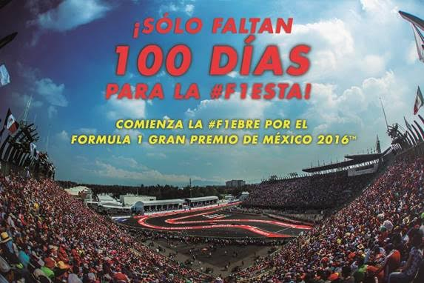

Today, July 22, there are only 100 days left for the F1EBRE to invade us and to see the checkered flag waving at the Autodromo Hermanos Rodriguez next October 30.

Emotions at the FORMULA 1 GRAN PREMIO DE MEXICO 2016™ will turn out perfectly for all the attendees, who will attest a great show.

On one side, competition in Aztec lands will be the number 19th of the championship, which means it would define the winner of 2016 – last year it was defined in Austin, a prior date to Mexico.

On the other hand, after the compounds alignment were announced, it is predicted that there will be more thrill and a higher speed on the track – it is even possible that record of 366 kph set in 2015 will be broken.

Finally, you will live the best F1ESTA of the championship and support Mexican drivers in their search for a place on the most thrilling podium of Formula 1.

Are ready to live the #F1EBRE of FORMULA 1 GRAN PREMIO DE MEXICO 2016™?

SAVE THE DATE: 30.10.16

-or-

www.mexicogp.mx
Facebook: mexicogp
Instagram/Twitter: @mexicogp
#MexicoGP #F1ESTA

Contact:
Francisco Velazquez  fvelazquezc@cie.com.mx  (52 55) 52019089  CIE | Manuel Orvañanos  manuel@bandofinsiders.com  (52 55) 63866686  Band of Insiders

About CIE
Corporacion Interamericana de Entretenimiento, S.A.B de C. V.

www.cie.com.mx
We are the market leader in outdoor entertainment in Mexico, Colombia and Central America and one of the major players in the entertainment industry in Latin America and across the globe.
CIE offers a variety of world-class entertainment options including concerts, theater productions, and sports and family and cultural events, among others, to meet our market segments’ needs for recreation and entertainment through its unique vertical integration model that provides the only access available to an extensive network of entertainment centers, advertisers including the principal advertising investors in our markets, and partnerships and strategic alliances with experienced global partners.
We operate an amusement and water park in Bogota, Colombia, and manage Centro Banamex in Mexico City, one of the largest convention and exhibition facilities across the globe. We are recognized as the foremost producer and organizer of special and corporate events in Mexico, and we operate one of the most professional contact centers in the Mexican market.
CIE is a public company whose shares and debt securities are listed on the Mexican Stock Exchange.

