Mexico City, October 17, 2016

Setting up the Autodromo Hermanos Rodriguez for the FORMULA 1 GRAN PREMIODE MEXICO 2016™

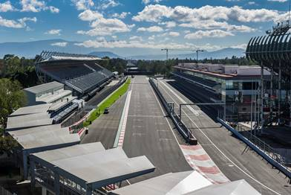

Download High Definition pictures on the following link:
https://we.tl/AUCniWxktD
Do not miss the FORMULA 1 GRAN PREMIO DE MEXICO 2016™!
Last available tickets are on sale at the Ticketmaster Network on the web page www.ticketmaster.com.mx, Ticketmaster authorized centers, calling 5325 9000 or at the ticket window no. 7 placed in Palacio de los Deportes.

For more information please go www.mexicogp.mx.
-or-
www.mexicogp.mx
Facebook: mexicogp
Instagram/Twitter: @mexicogp
#MexicoGP #F1ESTA #F1EBRE

Contact:
Francisco Velazquez  fvelazquezc@cie.com.mx  (52 55) 52019089  CIE | Manuel Orvañanos  manuel@bandofinsiders.com  (52 55) 63866686  Band of Insiders

About CIE
Corporacion Interamericana de Entretenimiento, S.A.B de C. V.
www.cie.com.mx
We are the market leader in outdoor entertainment in Mexico, Colombia and Central America and one of the major players in the entertainment industry in Latin America and across the globe.
CIE offers a variety of world-class entertainment options including concerts, theater productions, and sports and family and cultural events, among others, to meet our market segments’ needs for recreation and entertainment through its unique vertical integration model that provides the only access available to an extensive network of entertainment centers, advertisers including the principal advertising investors in our markets, and partnerships and strategic alliances with experienced global partners.
We operate an amusement and water park in Bogota, Colombia, and manage Centro Banamex in Mexico City, one of the largest convention and exhibition facilities across the globe. We are recognized as the foremost producer and organizer of special and corporate events in Mexico, and we operate one of the most professional contact centers in the Mexican market.
CIE is a public company whose shares and debt securities are listed on the Mexican Stock Exchange.

