Mexico City, November 1, 2016.

The F1ESTA says goodbye with National Lottery’s Sorteo Mayor

The FORMULA 1 GRAN PREMIO DE MEXICO 2016™success will be celebrated with a commemorative ticket.

Former driver and ambassador this year, Adrian Fernandez, attended the event.

In commemoration to the success reached during the second edition of FORMULA 1 GRAN PREMIO DE MEXICO™, promoters of the event together with the National Lottery carried out the Sorteo Mayor Number 3605 with $54 millions of pesos in prizes and refunds in 3 series- whose tickets of the special edition were illustrated with the event’s poster.

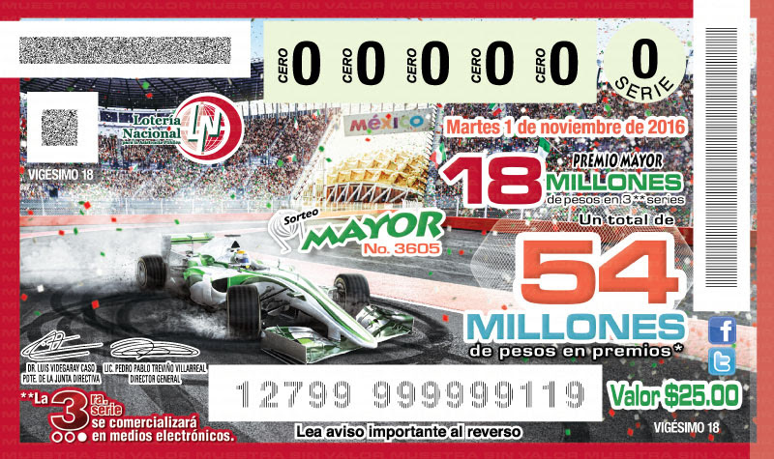

FORMULA 1 GRAN PREMIO DE MEXICO™ CEO, Federico González Compeán, and National Lottery’s Marketing Director, Javier Bolaños Cacho Martínez, led the ceremony that was also attended by the former driver and race’s ambassador, Adrián Fernández, who worked as witness of the raffle launch.

During the event, Federico González Compeán pointed the success of FORMULA 1 GRAN PREMIO DE MEXICO 2016™ which was attended by 339,967 people throughout the weekend after a sold out. Besides, he said, “Our F1ESTA left fans of motor racing top category, very pleased thanks to the audience’s energy and warmth which was once again what added that special zing to the weekend”.

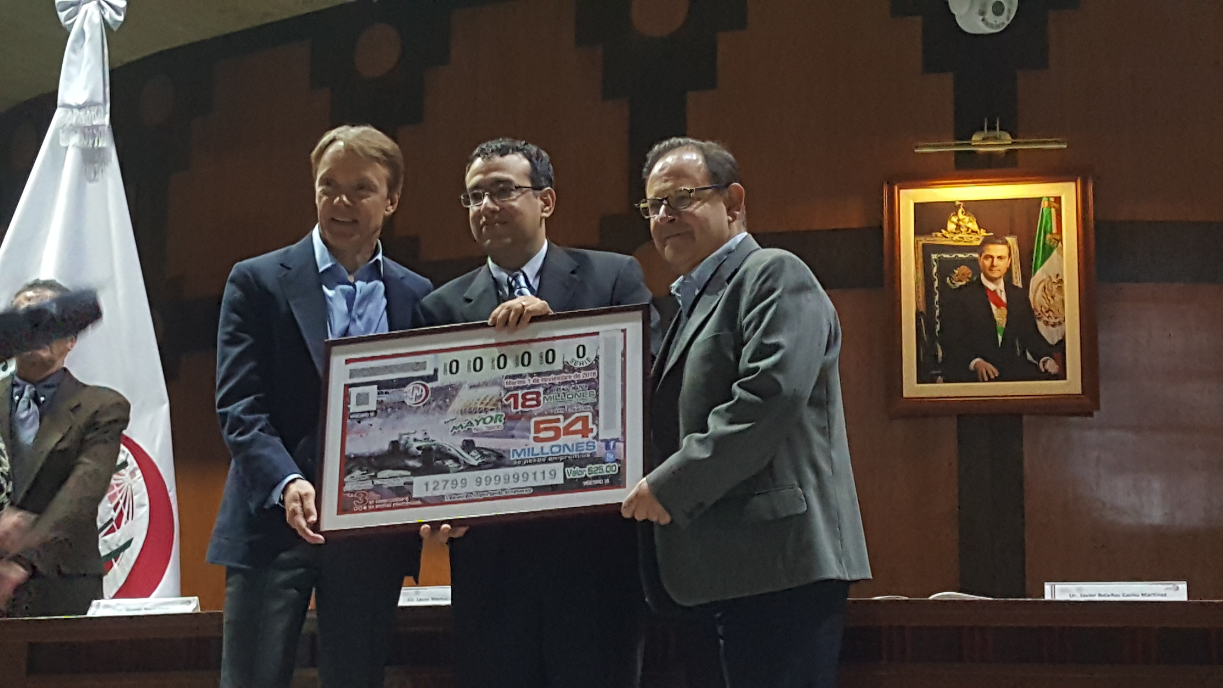

In addition, he took the opportunity to thank the participation of the National Lottery for being present at the Autódromo Hermanos Rodríguez with different points of sale where visitors were able to purchase their tickets for the raffle.

On the other hand, Javier Bolaños Cacho Martínez, National Lottery’s Marketing Director, acknowledged that FORMULA 1 GRAN PREMIO DE MEXICO 2016™’s success stood out given that Mexico was put in the world’s eyes again.

The Sorteo Mayor No. 3605, count with a main winner who took the prize for the total amount of $18 millions of pesos, with the ticket number 32918; a second prize for the amount of $1.5 million pesos was also awarded today, as well as a third prize for $750,000. There are a total of 18,760 prizes to be awarded.

At the end of the raffle there was a cocktail sponsored by Chandon.
Share

Tweet

Forward

-or-
www.mexicogp.mx
Facebook: mexicogp
Instagram/Twitter: @mexicogp
#MexicoGP #F1ESTA #F1EBRE
Contact:
Francisco Velázquez  fvelazquezc@cie.com.mx  (52 55) 52019089  CIE | Manuel Orvañanos  manuel@bandofinsiders.com  (52 55) 63866686  Band of Insiders

About CIE
Corporación Interamericana de Entretenimiento, S.A.B de C. V.
www.cie.com.mx
We are the market leader in outdoor entertainment in Mexico, Colombia and Central America and one of the major players in the entertainment industry in Latin America and across the globe.
CIE offers a variety of world-class entertainment options including concerts, theater productions, and sports and family and cultural events, among others, to meet our market segments’ needs for recreation and entertainment through its unique vertical integration model that provides the only access available to an extensive network of entertainment centers, advertisers, including the main advertising investors in our markets, and partnerships and strategic alliances with experienced global partners.
We operate an amusement and water park in Bogota, Colombia, and manage Centro Banamex in Mexico City, one of the largest convention and exhibition facilities across the globe. We are recognized as the foremost producer and organizer of special and corporate events in Mexico, and we operate one of the most professional contact centers in the Mexican market.
CIE is a public company whose shares and debt securities are listed on the Mexican Stock Exchange.

