Mexico City, June 12, 2017.

FORMULA 1 GRAN PREMIO DE MÉXICO 2017™ supports young mexican talent, through F1 in Schools™ Project.

- “F1 in Schools™ is an additional platform to our own aiming to spread national talent”, Federico González Compeán –General Director of FORMULA 1 GRAN PREMIO DE MÉXICO 2017™.
- F1 in Schools™ national finals will take place on June 23 and 24, at the Autódromo Hermanos Rodríguez during FORMULA 1 GRAN PREMIO DE MÉXICO 2017™.

In order to promote and support our national young talents, the FORMULA 1 GRAN PREMIO DE MÉXICO 2017TM has partnered with Fundación Persiste A.C. through F1 in Schools™ project. It is about an educational initiative present in over 20 countries around the world, aiming to promote science, technology, mathematics and wit among students at the time it encourages the procedures that any FORMULA 1® team has to go through in real life.

The F1 in Schools™ challenge – involves collaborating with the training of young contestants - who are generally from 11 and 19 years old– being a platform to develop skills in different disciplines such as marketing, design, management and science; it also offers a first approach with the real job world.
This way, students - who should be grouped in teams of 3 to 6 individuals – they must design a business plan that includes, among others, sponsorship activities and spreading in social media, also designing and building a miniature car able to compete against other teams. Afterwards, regional competitions will be organized so competitors justify their team strategy in front of a judge panel that will rate them.

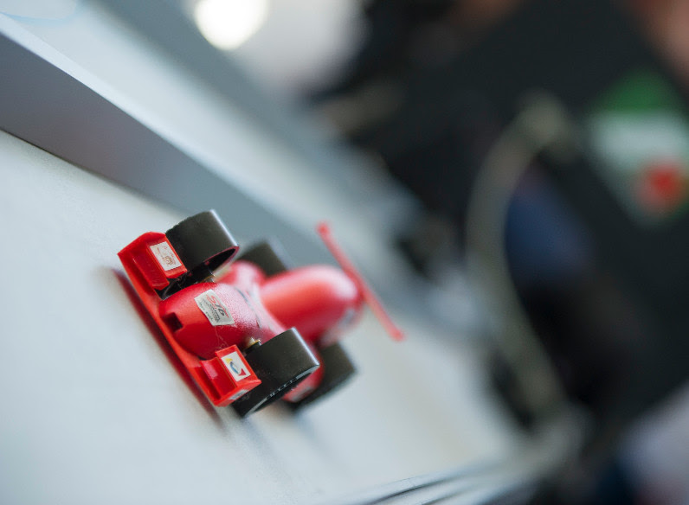

“One of the main goals for FORMULA 1 GRAN PREMIO DE MÉXICOTM is promoting our country around the world, as well as demonstrating our people’s ability. Consequently, in addition to our own event, F1 in Schools™ for us is a platform that spreads national young talent”, said the General Director of FORMULA 1 GRAN PREMIO DE MÉXICO 2017™, Federico González Compeán. “We are proud to join this effort, and so showing how well things are done in Mexico”, stated.

Only two years away from having started activities in Mexico, F1 in Schools™ has now 103 participating teams- from which most of them belong to public schools. A total of 618 students are directly participating and 100,000 indirectly; the 70% of them comprised by men and 30% women.

“The Formula 1® world, together with scientific and technological work are the perfect scenery to encourage young people to choose scientific and engineering careers. To Persiste A.C., it is an honor to work together with FORMULA 1 GRAN PREMIO DE MÉXICO™ on this effort”, said Professor Héctor Tello García, CEO of Persiste A.C. and Mexico’s representative for F1 in Schools™.

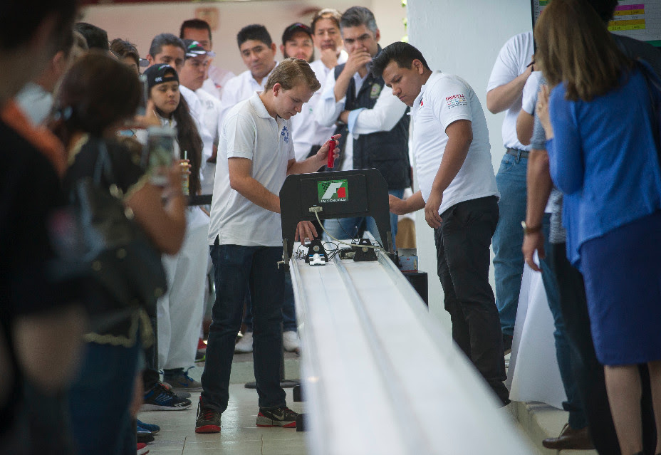

After having carried out the regional qualifiers in eight different States of the Republic, the best teams of each locality* will be in the nationals that will take place on June 23 and 24 at the Autódromo Hermanos Rodríguez – venue of FORMULA 1 GRAN PREMIO DE MÉXICO 2017™.

Besides showing their acquired skills, three teams will be chosen on that last competition, to travel to Malaysia representing Mexico for the global final in September, when the best young talent from the rest of the participating countries will be competing. Once there, the goal is getting victorious and winning among other prizes, the coveted place in the training program of Formula 1®‘s team, Williams Racing.

*A document with F1 in Schools™ México‘s National Finals detailed participating teams is attached separately.

For more information on the initiative and pictures downloading, click on the following link:
https://we.tl/Ud8gjJRDtV

For more information: www.mexicogp.mx and www.f1inschools.mx
#MexicoGP #F1ESTA

Press contacts:
CIE  Francisco Velázquez  Press Manager  T. 5201-9089  fvelazquezc@cie.com.mx | MAKKEN  María Torres Farber  Account Director  T. (55) 41600 800 / 900  maria.torres@makken.com.mx | FUNDACIÓN PERSISTE  Paulina Guanes  Public Relations Manager  T. 5513575347  pguanes@persiste.org.mx

About FORMULA 1 GRAN PREMIO DE MÉXICO™:
The highest category in motor racing has returned to Mexico, after 23 years of absence, pioneer of the greatest sport events in our country. With a term from 2015 to 2019 the renewed Autódromo Hermanos Rodríguez is the perfect stage for the return of the F1ESTA to our country, with a highest world-class level track. On its first two editions (2015 and 2016), over 375 thousand people attending the race, turned into the second with the biggest number of spectators around the world (after Great Britain). Until now, FORMULA 1 GRAN PREMIO DE MÉXICO™ has generated over 22 thousand jobs, economic revenue of 1,119 MDD (24,841 million of pesos). One more year, Mexico will create a world-class position during racing that will take place from October 27th, to October 29th, after having been awarded as the Best Event of the Year by the maximum authorities in world professional motor racing FIA and FOM, during its first two editions. For further information about FORMULA 1 GRAN PREMIO DE MÉXICO™ go: http://www.mexicogp.mx/

About Formula 1®:
Formula 1® is the most prestigious motor racing competition in the world that has taken the position of the most popular annual sport competition in the planet: In 2016 the championship was witnessed by 400 million of viewers only from over 200 places.
With a long history of glory and racing written since 1950, Formula 1® has been bastion for great drivers, as well as for iconic teams that had led motor racing to being part of collective memory in millions of fans all around the world.
In 2016 FIA Formula One World Championship™ took place from March to November, including 21 races in 21 countries of the five continents. Formula One World Championship Limited is part of Formula 1® and owns the exclusive commercial rights to FIA Formula One World Championship™.
Formula 1® has being raced in Mexico for 17 times, being editions 2015 and 2016 recognized as “The best Grand Prix of the world”. For further information about Formula 1® go to: : www.formula1.com

About CIE
Corporación Interamericana de Entretenimiento, S.A. de C. V. www.cie.com.mx
We are the market leader in outdoor entertainment in Mexico, Colombia and Central America and one of the major players in the entertainment industry in Latin America and across the globe.
CIE offers a variety of world-class entertainment options including concerts, theater productions, and sports and family and cultural events, among others, to meet our market segments’ needs for recreation and entertainment through its unique vertical integration model that provides the only access available to an extensive network of entertainment centers, advertisers, including the main advertising investors in our markets, and partnerships and strategic alliances with experienced global partners.
We operate an amusement and water park in Bogota, Colombia, and manage Centro Banamex in Mexico City, one of the largest convention and exhibition facilities across the globe. We are recognized as the foremost producer and organizer of special and corporate events in Mexico, and we operate one of the most professional contact centers in the Mexican market.
CIE is a public company whose shares and debt securities are listed on the Mexican Stock Exchange.

