Mexico City, June 26th, 2017.

The FORMULA 1 GRAN PREMIO DE MÉXICOTM together with Fundación Persiste A.C. continue encouraging national talent towards F1 in SchoolsTM Finals to be held at the Autódromo Hermanos Rodríguez

- “F1 in Schools™’ contestants labor is a clear example of the huge potential present in Mexico, therefore we thank all contestants for helping us to foster a positive face of our country”, said Diego Pérez Palacios - Business Manager of FORMULA 1 GRAN PREMIO DE MÉXICO 2017™
- The teams Alebrijes, Innova Racing by Panteras and Irruenti, from schools CONALEP in Puebla, U.P. Prepa de CDMX and Cobach from Sonora, will respectively represent Mexico before other forty four countries at the Grand World Final in Malaysia, next September.
The FORMULA 1 GRAN PREMIO DE MÉXICO™ keeps on promoting the best of Mexico to the world and last weekend, it was achieved together with Fundación Persiste A.C. supporting the youngest talent of our country. On Friday 23 and Saturday 24, June, the F1 in SchoolsTM National Finals were held at the Autódromo Hermanos Rodríguez, venue of the Mexican Grand Prix, where these young students’ business plans and their scale model cars were tested to win the competition.
Alebrijes, Innova Racing by Panteras and Irruenti, from schools CONALEP in Puebla, U.P. Prepa de CDMX and Cobach in Sonora, were respectively chosen as the three best performance teams. This way, these young people will respectively be the proud Mexico’s representatives at the F1 Schools TM Gran World Final to be held in Kuala Lumpur next September, in parallel to the Mexican Grand prix, where teams from over 40 countries will compete.

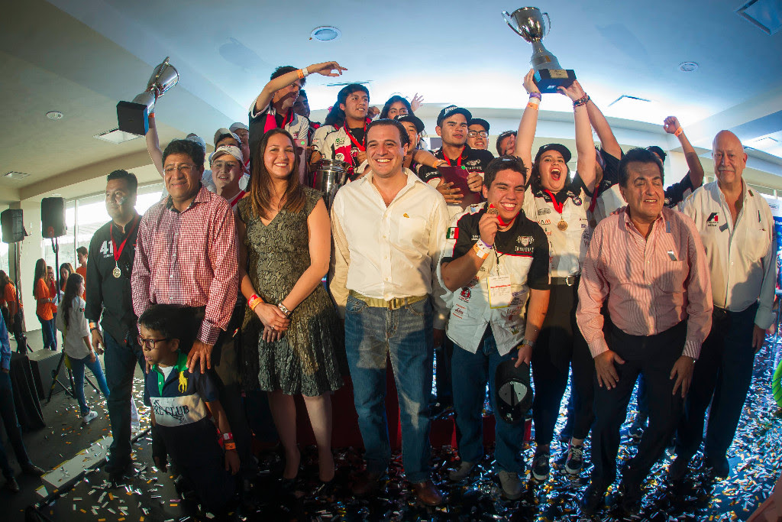

F1 in Schools™’ contestants labor is a clear example of the huge potential present in Mexico, therefore we thank all contestants for helping us to foster a positive face of our country”, said Diego Pérez Palacios - Business Manager of FORMULA 1 GRAN PREMIO DE MÉXICO 2017™, during the recognition to “Outstanding Team Leader” of the award ceremony.
“We expect passion for motor racing in our country grows thanks to initiatives like this, so that we will have more drivers like Checo Pérez, Adrián Fernández or Jo Ramírez in a future”, stated the director.
That way it concluded, a successful second edition of this educational initiative program, F1 in Schools™ in Mexico, which aims to Foster science, technology, mathematics and creativity among students, and simultaneously it emulates the procedures that all FORMULA 1® teams have to get through in real life.
“The experience lived in F1 in SchoolsTM is the best alternative that we in Fundación Persiste have found, for the young people to reach a meaningful learning of science, technology and mathematics, as well as the development of 21’st century skills. It is a perfect example of a project implementation”, said President of Persiste A.C. and F1 in Schools™ in México Representative, Professor Héctor Tello García.

During World Final, contesting teams will try to get among other prizes, a position inside Williams Racing’s team developing program.

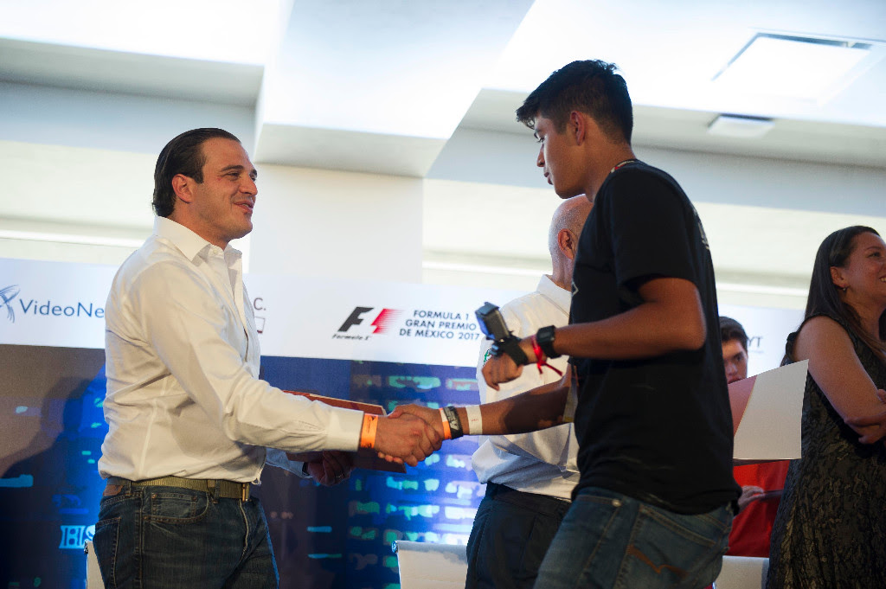

A MAJOR LEAGUES INSPIRATION
During the award ceremony, where there were experienced a number of emotions along with these young fans of motor racing, speed and technology, Jo Ramirez, Formula 1® Mexican legend and FORMULA 1 GRAN PREMIO DE MÉXICO 2017TM ambassador, encouraged the contestants through a conference call from Europe.

“As you can see, during the preparation for the final, team work is essential for a project to succeed: devotion, enthusiasm, friendship and fellowship. That is all also what Formula 1® teams need, from engineers to drivers, we work all together on a same goal: winning”, said McLaren’s former coordinator and a good friend of deceased Ayrton Senna, who also shared some anecdotes about his intense career.
Download photos of the Final on the following link: https://we.tl/psVaqcIgre
For further information go: www.mexicogp.mx y www.f1inschools.mx

WWW.MEXICOGP.MX
#MexicoGP #F1ESTA
Press Contact

CIE
Francisco Velázquez
Press Manager
T. 5201-9089
fvelazquezc@cie.com.mx

MAKKEN
María Torres Farber
Account Director
T. (55) 41 600 800 / 900
maria.torres@makken.com.mx

About FORMULA 1 GRAN PREMIO DE MÉXICO™:
The highest category in motor racing has returned to Mexico, after 23 years of absence, pioneer of the greatest sport events in our country. With a term from 2015 to 2019 the renewed Autódromo Hermanos Rodríguez is the perfect stage for the return of the F1ESTA to our country, with a highest world-class level track. On its first two editions (2015 and 2016), over 375 thousand people attending the race, turned into the second with the biggest number of spectators around the world (after Great Britain). Until now, FORMULA 1 GRAN PREMIO DE MÉXICO™ has generated over 22 thousand jobs, economic revenue of 1,119 MDD (24,841 million of pesos). One more year, Mexico will create a world-class position during racing that will take place from October 27th, to October 29th, after having been awarded as the Best Event of the Year by the maximum authorities in world professional motor racing FIA and FOM, during its first two editions. For further information about FORMULA 1 GRAN PREMIO DE MÉXICO™ go: http://www.mexicogp.mx/

About Formula 1®:
Formula 1® is the most prestigious motor racing competition in the world that has taken the position of the most popular annual sport competition in the planet: In 2016 the championship was witnessed by 400 million of viewers only from over 200 places.
With a long history of glory and racing written since 1950, Formula 1® has been bastion for great drivers, as well as for iconic teams that had led motor racing to being part of collective memory in millions of fans all around the world.
In 2016 FIA Formula One World Championship™ took place from March to November, including 21 races in 21 countries of the five continents. Formula One World Championship Limited is part of Formula 1® and owns the exclusive commercial rights to FIA Formula One World Championship™.
Formula 1® has being raced in Mexico for 17 times, being editions 2015 and 2016 recognized as “The best Grand Prix of the world”. For further information about Formula 1® go to: : www.formula1.com

About CIE:
Corporación Interamericana de Entretenimiento, S.A. de C. V. www.cie.com.mx
We are the market leader in outdoor entertainment in Mexico, Colombia and Central America and one of the major players in the entertainment industry in Latin America and across the globe.
CIE offers a variety of world-class entertainment options including concerts, theater productions, and sports and family and cultural events, among others, to meet our market segments’ needs for recreation and entertainment through its unique vertical integration model that provides the only access available to an extensive network of
entertainment centers, advertisers, including the main advertising investors in our markets, and partnerships and strategic alliances with experienced global partners.
We operate an amusement and water park in Bogota, Colombia, and manage Centro Banamex in Mexico City, one of the largest convention and exhibition facilities across the globe. We are recognized as the foremost producer and organizer of special and corporate events in Mexico, and we operate one of the most professional contact centers in the Mexican market.
CIE is a public company whose shares and debt securities are listed on the Mexican Stock Exchange.

